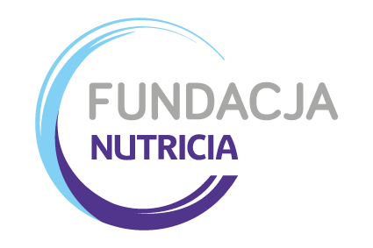

INSTRUCTIONS, TERMS AND CONDITIONS

- Please use the attached form to provide all information pertinent to your research project. You may use additional pages if needed. The application will be reviewed by the Scientific Council and the Foundation Management of the Foundation.
- The form must also be signed by an appropriate authority in the institution in which the work will be done.
- It is the responsibility of the applicant to obtain a specific approval for this project from the local ethical committee. An affirmative letter from such a committee should be attached to the application form.
- The grant should be spent only on items specified in the budget sheet included in the application. Please note that the Nutricia Foundation in principle does not support overhead charges, travel costs or investments in permanent equipment. If the research project involves the use of human volunteers, payment for volunteers would be accepted. Personnel costs cannot exceed 25% of the total budget. Payment for the main researcher and collaborators will be accepted. Payment for insurance (if applicable) will be accepted. Budget should be expressed in Polish zloty (PLN) and should include VAT and any indirect (maximum 20% of total budget) costs that may occur.
- Project grants are available for a maximum of 2 years, plus one year for publications. By the end of each stage a progress report has to be submitted, on the basis of such report the Foundation will decide of the continuation of the grant into a next stage. Payment of the grant by Nutricia Foundation will be made periodically or on an annual basis. The Foundation reserves the right to terminate a grant if the grantee does not comply with the terms and purpose of the grant. Detailed regulations re. grant financing and responsibilities of parties are described in grant agreement.
- Any publication on the project should make reference to the grant as following (in Polish or in English):
“Pracę wykonano w ramach projektu badawczego Nr ... finansowanego/ dofinansowywanego przez Fundację NUTRICIA” or „Study sponsored by a grant no. … obtained from NUTRICIA Foundation”. A reprint of any published work should be sent to the Nutricia Foundation.
- Receipt date for application unless otherwise agreed upon, is June 30th.
- Completed and signed form please send to: granty.naukowe@fundacjanutricia.pl. All applications will receive answer. Project can be accepted or rejected for funding.
- All decisions undertaken by the Committee are final and not subject to appeal.

